This form must be completed and submitted by **all teams no later than the date specified in the Action Deadlines on specific event website**. The FSAE Technical Committee will review all submissions which deviate from the FSAE® rulesand reply with a decision about the requested deviation. All requests will have a confirmation of receipt sent to the team.Impact Attenuator Data (IAD) and supporting calculations must be submitted electronically in Adobe Acrobat Format(*.pdf). The submissions must be named as follows: schoolname_IAD.pdf using the complete school name. **Submit the IAD report as instructed on the event website. For Michigan and Lincoln events submit through fsaeonline.com.**

*In the event that the FSAE Technical Committee requests additional information or calculations, teams have **one week from the date of the request** to submit the requested information or ask for a deadline extension.

University Name: __Polytechnique Montréal Car Number(s) & Event(s): _78 @ Michigan_

Team Contact: __Renaud Pepin E-mail Address: renaud.pepin@polymtl.ca

Faculty Advisor: __Eduardo Olivera E-mail Address: eduardo.olivera@polymtl.ca

|  |  |
| --- | --- |
| Material(s) Used | Formula SAE Standard Impact Attenuator |
| Description of form/shape | Pyramidal |
| IA to Anti-Intrusion Plate mounting method | Loctite EA E-30UT |
| Anti-Intrusion Plate to Front Bulkhead mounting method | Welded |
| Peak deceleration (<= 40 g's) | Standard Impact attenuator |
| Average deceleration (<= 20 g's) | Standard Impact attenuator |

Confirm that the attenuator contains the minimum volume 200mm wide x 100mm high x 200mm long

|  |
| --- |
| Standard Impact attenuator |

Figure 1: Force-Displacement Curve (dynamic tests must show displacement during collision and after the point v=0 and until force becomes = 0)

**ATTACH PROOF OF EQUIVALENCY**

TECHNICAL COMMITTEE DECISION/COMMENTS

_______________________________________________________________________________________

Approved by__________________________________________ Date_____________

**NOTE: THIS FORM AND THE APPROVED COPY OF THE SUBMISSION MUST BE PRESENTED**

**AT TECHNICAL INSPECTION AT EVERY FORMULA SAE EVENT ENTERED**

University Name: __Polytechnique Montréal__ Car Number(s) & Event(s): __78 @ Michigan___

|  |
| --- |
| Standard Impact attenuator |

Figure 2: Energy-Displacement Curve (dynamic tests must show displacement during collision and after v=0)

|  |  |  |
| --- | --- | --- |
| Insert Picture of IA, Anti-Intrusion Plate which also shows the method of spacing it at least 50mm from any rigid structure |  | Insert Picture of IA, Anti-Intrusion Plate which shows the deflection was less than 25.4mm |

Figure 3: Attenuator as Constructed Figure 4: Attenuator after Impact

|  |  |  |  |
| --- | --- | --- | --- |
| Energy Absorbed (J):  Must be >= 7350 J |  | Vehicle includes front wing in front of front bulkhead? | No |
| IA Max. Crushed Displacement (mm): |  | Wing structure included in test? | - |
| IA Post Crush Displacement - demonstrating any return (mm): |  | Test Type: (e.g. barrier test, drop test, quasi-static crush) |  |
| Anti-Intrusion Plate Deformation (mm) |  | Test Site: (must be from approved test site list on website for dynamic tests) |  |

University Name: __Polytechnique Montréal__ Car Number(s) & Event(s): __78 @ Michigan___

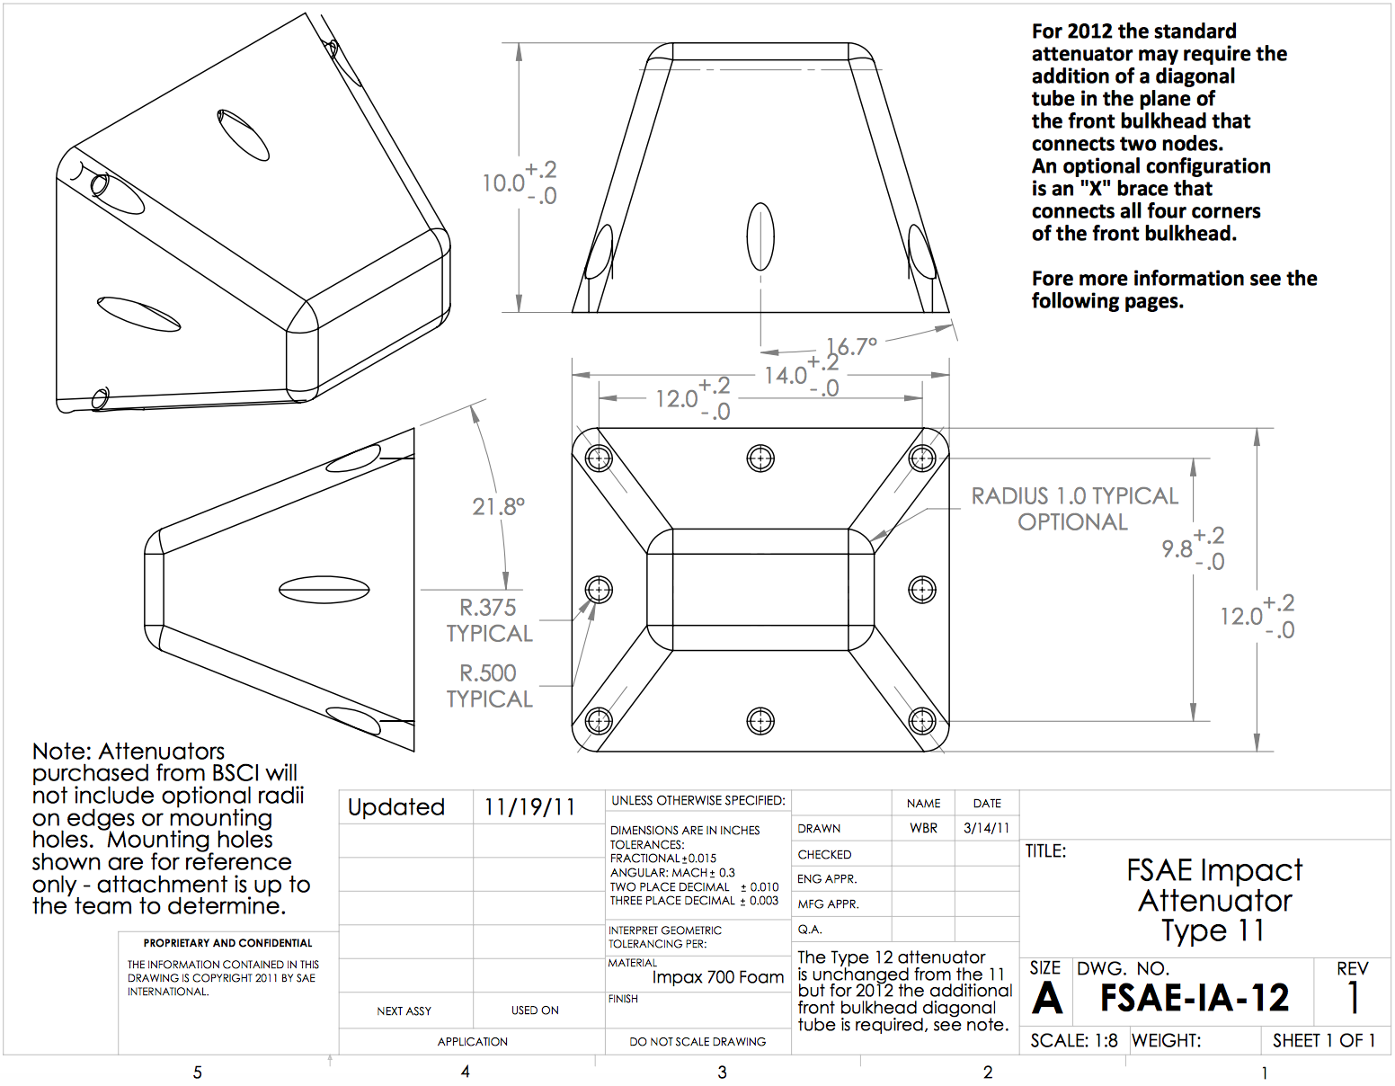

Length (fore/aft direction): 254 mm (>=200mm)

Width (lateral direction): 304.8 mm (>=200mm)

Height (vertical direction): 355.6 mm (>=100mm)

Attenuator is at least 200mm wide by 100mm high for at least 200mm: Yes

***Attach additional information below this point and/or on additional sheets***

Impact Attenuator Report – Polytechnique Montréal (car # )

**Introduction**

This year, the team decided to use the standard impact attenuator (IA) type 12 like the past year, but to reduce the front bulkhead to the minimum dimension possible. It will be bonded to a 0.060in steel anti-intrusion plate (AIP). The use of a steel AIP allows it to be welded to the front bulkhead. No diagonal is used in the front bulkhead since the distance between the impact attenuator and the front bulkhead tubes complies with the rules.

**Design of impact attenuator and positioning to the anti-intrusion plate**

The standard impact attenuator type 12 bought at BSCI was chosen. The orientation of the IA on the AIP is vertical as shown on Figure 1 below. The IA is fixed to the AIP with Loctite EA E-30UT.

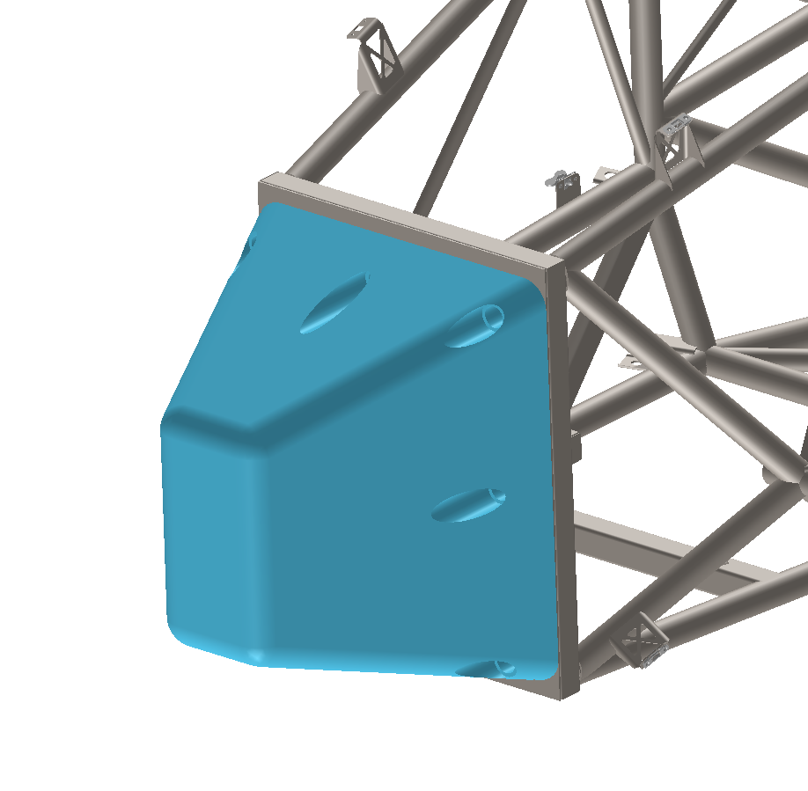

Figure 1. Orientation of the impact attenuator

**Dimensions of the front bulkhead**

The dimensions of the front bulkhead are shown in figure 2. As shown in figure 3, the outside profile of the anti-intrusion plate does not extend beyond the Standard impact attenuator by more than 1in (25mm), as per rule T3.20.6. Therefore, no diagonal steel tube is required in the design of the front bulkhead. The front bulkhead was designed to have the minimal dimensions required to incorporate a Standard impact attenuator in order to minimize weight. The overlap of the impact attenuator over the front bulkhead tubes is shown in figure 4.

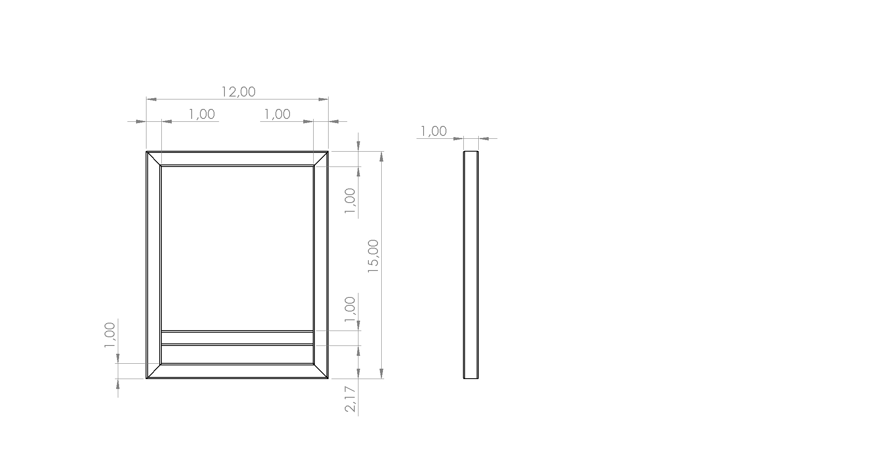

figure 2. Front bulkhead dimensions

**Design of the Anti-Intrusion Plate**

The welded anti-intrusion plate is made out of a 0.060in (1.5mm) solid steel plate as per rule T3.20.3. The anti-intrusion plate is 12.00in X 15.00in to match the front bulkhead size, and therefore extends past the centerline of the front bulkhead tubes on all sides as per rule T3.20.5.

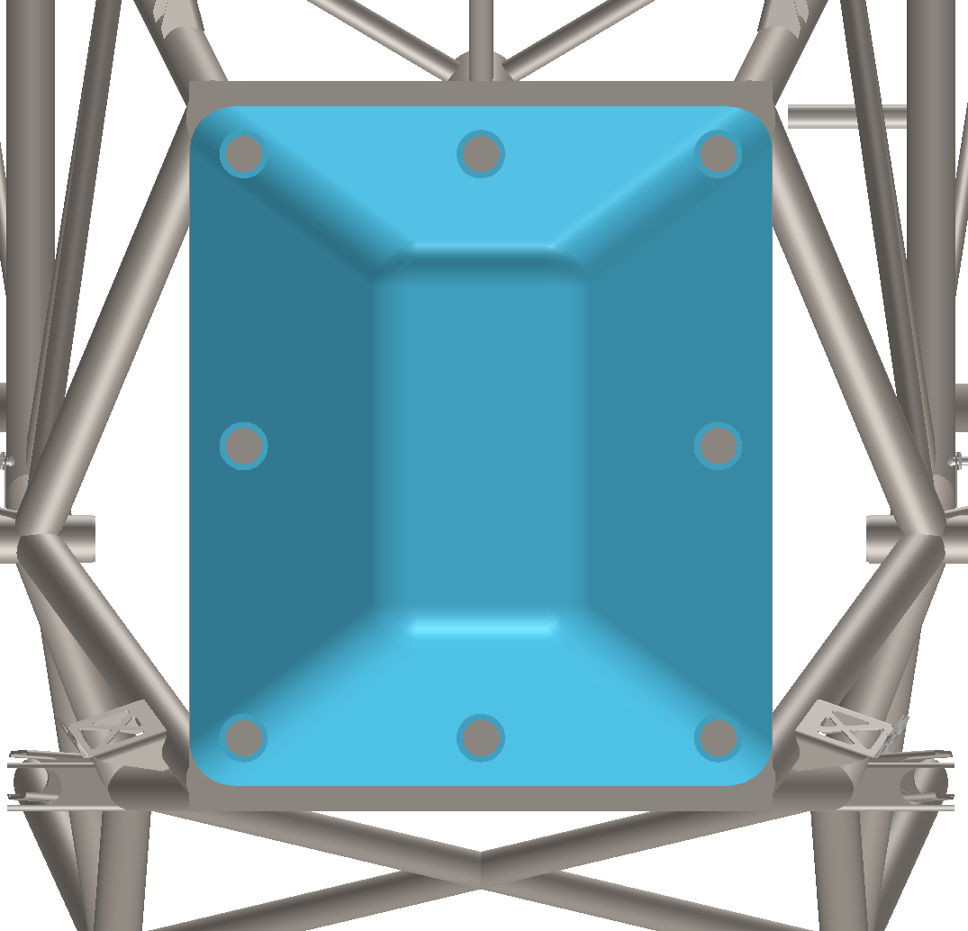 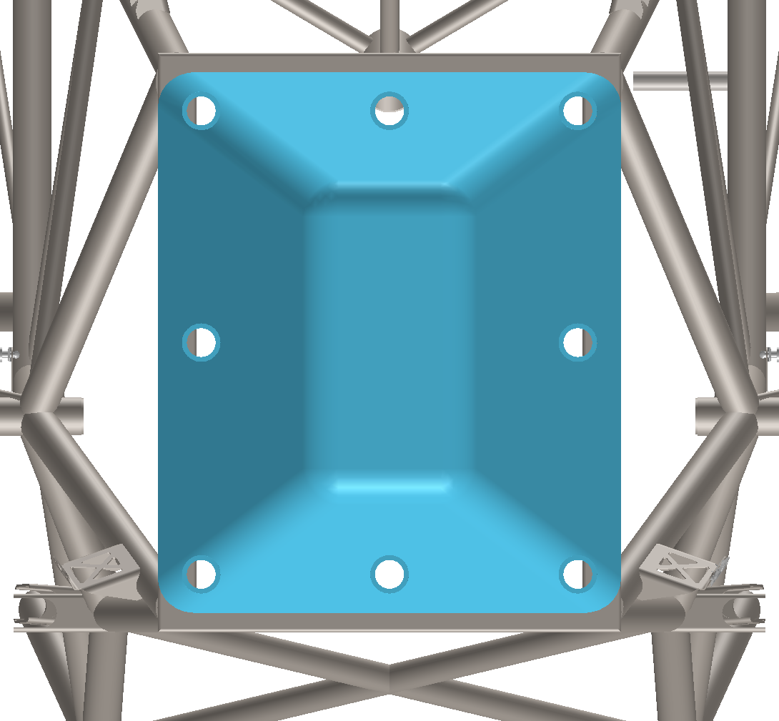

Figure 3. Outside profile of Anti-Intrusion plate Figure 4. Outside profile of Impact Attenuator

**Attachment method of the impact attenuator**

The impact attenuator is bonded to the anti-intrusion plate with Loctite EA E-30UT epoxy adhesive. As such, no additional fasteners are required. This adhesive was chosen for its good shear resistance of 29MPa for steel. It also cures at ambient temperature within three hours.

**Attachment method of the anti-intrusion plate**

The anti-intrusion plate will be welded to the front bulkhead. The welds will be interrupted welds of at least 1in (25mm) in length with spacing of less than 1in (25mm) each, as per rule T3.20.4. Welding the anti-intrusion plate allows the bulkhead size to be smaller than when fixing it with bolts, as there is no need for the plate’s exterior profile to be greater than the exterior profile of the impact attenuator. It also allows for a narrower front bodywork design.

**Conclusion**

This report shows that the Impact Attenuator Assembly of Polytechnique Montreal’s car, including the Impact Attenuator and Anti-Intrusion plate, is in compliance with all Formula Student rules.

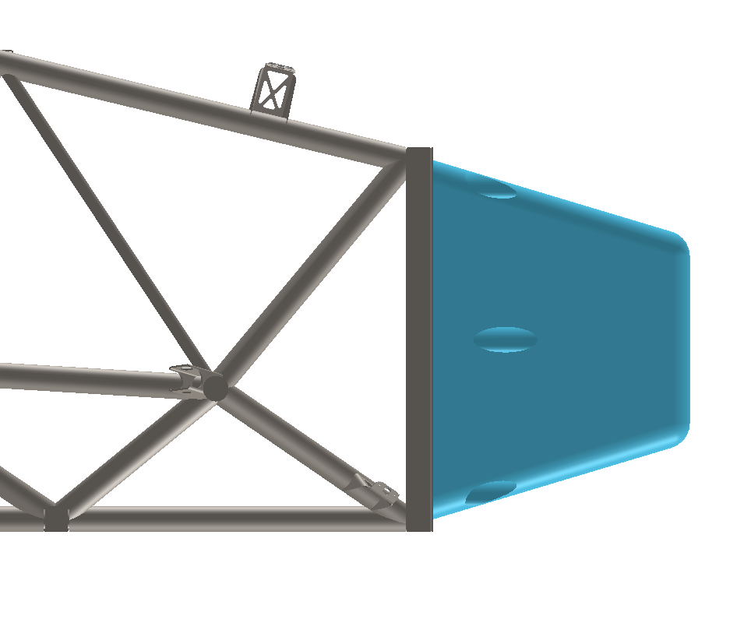

Figure 5. Side view of Impact Attenuator Assembly